Software Design Document
AI-Based Job Market Intelligence and Resume Analysis System



Submitted by:
Muhammad Shahid (S23BINFT1E02054)

Submitted to
Dr. Musarat Karim

Department of Information Technology
Faculty of Computing

The Islamia University of Bahawalpur

REVISION HISTORY

Meetings Details
Sr No | Details | Date | Techer Signature
1 | Discussed project idea and basic SDD structure, received initial feedback. | 10/4//2026
2 | Defined detailed uml diagrams and got suggestions for improvement. | 19/4/2026
3 | Finalized SDD, applied changes, and received approval. | 30/4/2026

TABLE OF CONTENTS

Chapter 1 — Introduction 5
1.1 Purpose of the SDD 5
1.2 Scope 5
1.3 Intended Audience 5
1.4 Design Principles 6
1.5 Document Conventions 6
1.6 References 6
Chapter 2 — Methodology 7
2.1 Development Methodology 7
2.2 Design Process 7
2.3 Technology Selection Rationale 7
2.4 Quality Assurance Methodology 8
Chapter 3 — System Architecture 9
3.1 Architectural Style 9
3.2 System Context Diagram (C4 Level 1) 9
3.3 Container Diagram (C4 Level 2) 9
3.4 Microservices Overview 10
3.5 Deployment Architecture Diagram 11
3.6 Component Diagram (UML) 11
3.7 Data Architecture 12
3.8 ER Diagram — Core Entities 13
3.9 Class Diagram — Resume Analysis Domain 13
Chapter 4 — User Interface Design 15
4.1 UI Design Principles 15
4.2 Design System 15
4.3 Screen Wireframes (Textual Representation) 15
4.4 Navigation Flow 17
4.5 Responsive Breakpoints 17
Chapter 5 — UML Diagrams 18
5.1 Use Case Diagram — Full System 18
5.2 Activity Diagram — Resume Analysis Workflow 18
5.3 Activity Diagram — Job Matching Workflow 19
5.4 Sequence Diagram — Resume Upload and Analysis 20
5.5 Sequence Diagram — User Authentication (MFA) 20
5.6 State Machine Diagram — Resume Lifecycle 21
5.7 State Machine Diagram — Job Posting Lifecycle 22
5.8 Sequence Diagram — Employer Posts a Job 22
5.9 Activity Diagram — Career Path Recommendation 23
Chapter 6 — References 25
Appendix A — Glossary 25
Appendix B — Architecture Decision Records (ADR) Summary 27

Chapter 1 — Introduction

1.1 Purpose of the SDD
This Software Design Document (SDD) provides a comprehensive architectural and detailed design description of the AI-Based Job Market Intelligence and Resume Analysis System (AJMIRAS). It translates the requirements established in the SRS into a blueprint for construction, specifying the system architecture, component design, interface design, and data design necessary for developers to implement the system.
This document is the authoritative reference for software architects, developers, database engineers, and QA teams throughout the implementation phase. All design decisions recorded here are derived directly from the functional and non-functional requirements defined in the SRS v1.2.

1.2 Scope
AJMIRAS is a cloud-native SaaS platform combining real-time job market intelligence with AI-powered resume evaluation. This SDD covers:
- System architecture and technology stack selection
- Microservices component breakdown and interactions
- Database schema and data flow design
- User interface design specifications and wireframes (textual)
- Security, scalability, and deployment architecture
- Complete UML diagram suite: Use Case, Activity, Sequence, Class, Component, Deployment, State Machine, and ER diagrams

1.3 Intended Audience
Audience | Role | Relevant Chapters | Priority
Software Architects | System design decisions | Ch. 1, 2, 3 | Critical
Backend Developers | Service & API implementation | Ch. 2, 3, 4 | Critical
Frontend Developers | UI & component building | Ch. 4, 5 | High
Database Engineers | Schema & query design | Ch. 3, 6 | High
QA / Test Engineers | Test planning & validation | Ch. 2, 3, 4, 5 | High
Project Manager | Oversight & planning | Ch. 1, 2 | Medium
Security Team | Threat modelling & audits | Ch. 3, 6 | High

1.4 Design Principles
- Separation of Concerns — Each microservice owns a single business capability.
- API-First Design — All inter-service and external communication via versioned REST APIs.
- Scalability by Default — Stateless services; horizontal scaling via Kubernetes HPA.
- Security-in-Depth — Defence at every layer: network, application, data, and identity.
- Fail-Safe Defaults — Circuit breakers, graceful degradation, and bulkhead patterns applied throughout.
- Ethical AI — Explainable, bias-audited models; human-override mandatory on hiring decisions.

1.5 Document Conventions
This document uses IEEE/ISO 42010 architecture description conventions. UML 2.5 notation is used for all diagrams. Requirements are cross-referenced by their SRS identifiers (FR-x.x, NFR-x). All diagrams are rendered as embedded SVG-based text representations within the document body.

1.6 References
- SRS — AI-Based Job Market Intelligence and Resume Analysis System v1.2 (2026)
- IEEE/ISO/IEC 42010:2011 — Systems and Software Engineering, Architecture Description
- The Twelve-Factor App Methodology — https://12factor.net
- OWASP Application Security Verification Standard (ASVS) v4.0
- AWS Well-Architected Framework, 2024 Edition
- Anthropic Claude API Documentation — https://docs.anthropic.com

Chapter 2 — Methodology

2.1 Development Methodology
AJMIRAS adopts an Agile Scrum methodology enhanced with Domain-Driven Design (DDD) for service decomposition. Development proceeds in two-week sprints across four phases:

Phase | Duration | Key Deliverables | Milestones
1 — Foundation | Sprints 1–3 | Core auth, resume upload, basic NLP pipeline | MVP Launch (Q3 2026)
2 — Intelligence | Sprints 4–7 | Job market engine, matching, dashboards | Beta Release (Q4 2026)
3 — Enrichment | Sprints 8–10 | Career paths, mobile PWA, employer analytics | GA Release (Q1 2027)
4 — Scale & Intl. | Sprints 11–14 | Multi-language, RTL UI, native mobile apps | Intl. Launch (Q2 2027)

2.2 Design Process
The design process follows a top-down decomposition approach:
- Step 1 — Requirements Analysis: Review SRS, identify bounded contexts via Event Storming.
- Step 2 — Architectural Design: Define system architecture, technology decisions, ADRs.
- Step 3 — Component Design: Detail each microservice's API contracts, data models, and logic.
- Step 4 — Interface Design: Produce UI wireframes, API schemas (OpenAPI 3.0).
- Step 5 — Validation: Architecture review board sign-off; SRS traceability matrix verified.

2.3 Technology Selection Rationale
Layer | Technology | Rationale | Alternatives Considered
Frontend | React 18 + TypeScript | Component reuse, strong ecosystem, SSR via Next.js | Vue 3, Angular
API Gateway | Kong / AWS API GW | Rate limiting, auth, analytics out-of-box | Nginx, Envoy
Services | Node.js + Python | Node for API services; Python for ML pipeline | Go, Java Spring
ML / NLP | Python + HuggingFace + Claude API | Best-in-class NLP; Claude for generative analysis | OpenAI GPT, spaCy only
RDBMS | PostgreSQL 15 | ACID compliance, JSONB support, proven at scale | MySQL, CockroachDB
Document DB | MongoDB 7 | Flexible schema for resume JSON documents | CouchDB, Firestore
Search | Elasticsearch 8 | Full-text + vector search for job/resume matching | Solr, Typesense
Cache / Queue | Redis 7 + Kafka | Redis for sessions/rate-limit; Kafka for async events | RabbitMQ, SQS
Orchestration | Kubernetes + Helm | Portable, auto-scaling, self-healing workloads | Docker Swarm, Nomad
CI/CD | GitHub Actions + ArgoCD | GitOps pipeline; environment parity | Jenkins, CircleCI

2.4 Quality Assurance Methodology
- Unit Testing: Jest (frontend), pytest (Python ML), Mocha/Chai (Node services) — target 80% coverage per SRS NFR.
- Integration Testing: Contract tests via Pact for all service-to-service APIs.
- End-to-End Testing: Playwright for critical user journeys (resume upload, job match, job post).
- Performance Testing: k6 load tests; must meet NFR-P targets (10,000 concurrent users, <10 s resume analysis).
- Security Testing: OWASP ZAP weekly scans; Snyk dependency audits in CI pipeline.
- AI Model Evaluation: F1-score >= 0.85 for NLP extraction; bias audits every 6 months.

Chapter 3 — System Architecture

3.1 Architectural Style
AJMIRAS follows a Microservices Architecture pattern, organized around bounded contexts identified via Domain-Driven Design. The architecture is cloud-native, containerized, and event-driven for asynchronous workloads. The system conforms to the C4 model (Context → Containers → Components → Code).

3.2 System Context Diagram (C4 Level 1)
The system context diagram identifies AJMIRAS and all external actors and systems it interacts with.
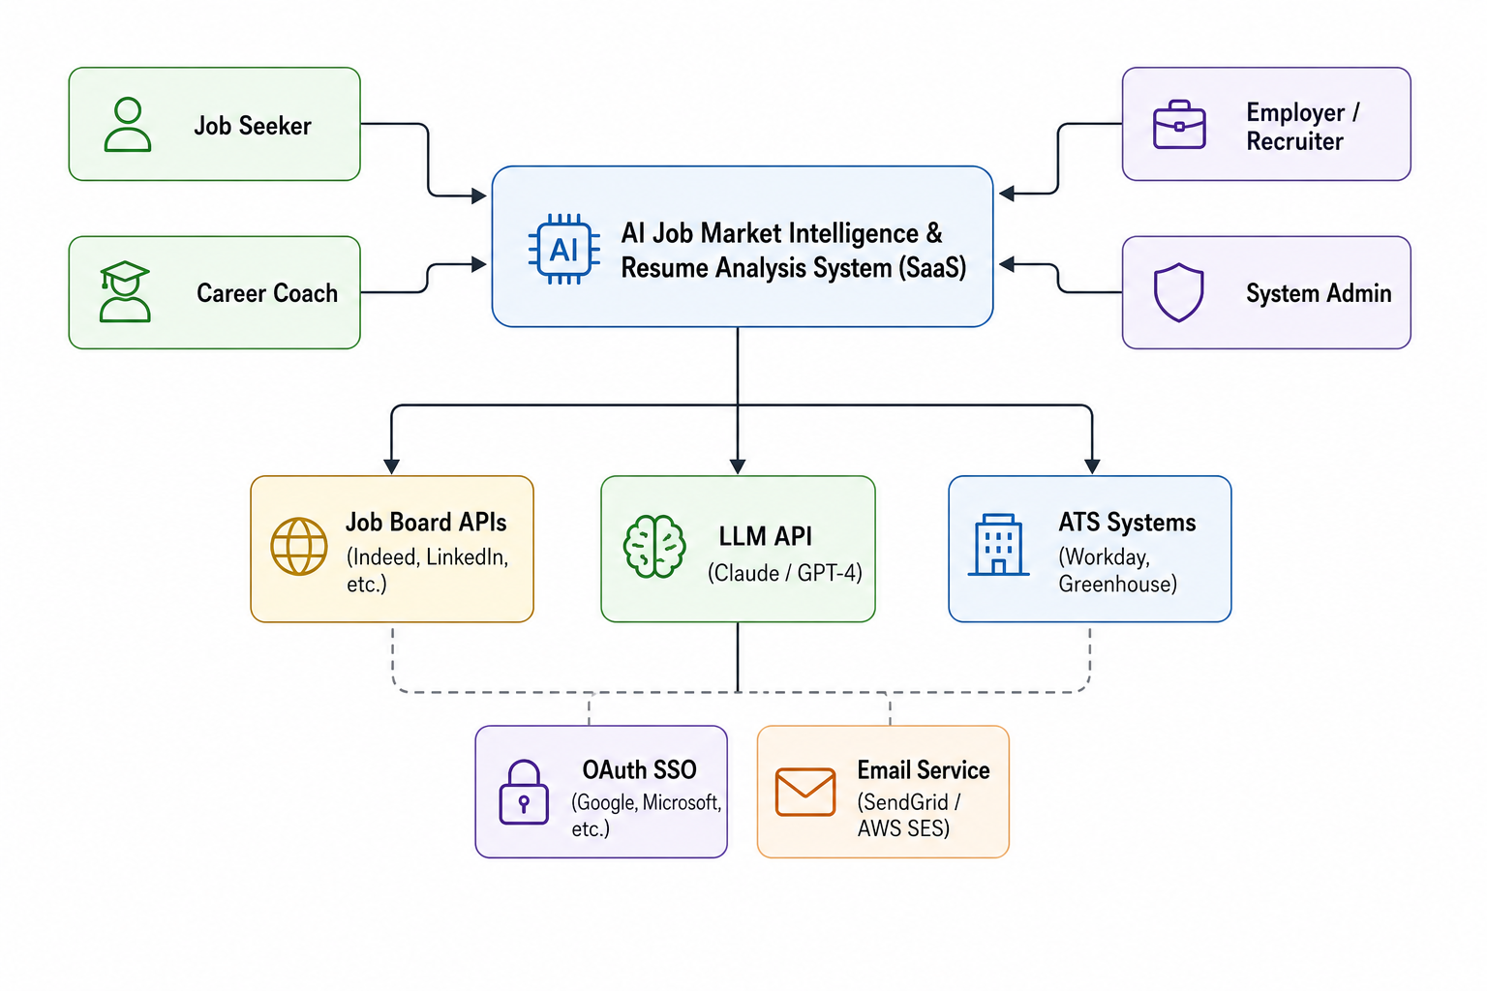

3.3 Container Diagram (C4 Level 2)
The container diagram shows the major deployable units within AJMIRAS and their relationships.

CONTAINER DIAGRAM — AJMIRAS PLATFORM
┌─ React SPA ─────────────────────┐ ┌─ Mobile PWA ──────────┐
│ (TypeScript, Next.js) │ │ (React Native Phase2)│
└────────────┬────────────────────┘ └──────────┬────────────┘
│ HTTPS / REST │
▼ ▼
┌─ API Gateway (Kong) ─────────────────────────────────────────┐
│ Rate Limiting │ Auth │ Load Balancing │ SSL Termination│
└───┬──────────┬──────────┬──────────┬──────────┬──────────────┘
│ │ │ │ │
▼ ▼ ▼ ▼ ▼
[Auth Svc] [Resume [Job Market [Match Svc] [Employer
Node.js Svc] Intel Svc] Python Analytics
Python Python Svc Node]
│ │ │ │ │
└──────────┴──────────┴──────────┴──────────┘
│ Event Bus (Kafka)
│
┌───────────────────┼───────────────────────┐
▼ ▼ ▼
[PostgreSQL 15] [MongoDB 7] [Elasticsearch 8]
Users/Jobs/Scores Resume Docs Job+Resume Search
│ │
└─────────── [Redis 7 Cache] ──────────────┘
Sessions / Rate-Limit
│
└─── [ML Pipeline Service] ──── [LLM API: Claude]
PyTorch / HuggingFace

3.4 Microservices Overview
Service | Tech Stack | Responsibilities | Key Dependencies
Auth Service | Node.js + JWT | Registration, login, MFA, OAuth SSO, RBAC token issuance | PostgreSQL, Redis, SendGrid
Resume Service | Python + FastAPI | Upload, parse (PDF/DOCX/TXT), NLP extraction, scoring, storage | MongoDB, ML Pipeline, Claude API
Job Market Service | Python + FastAPI | Job data ingestion, classification, trend analysis, salary stats | Elasticsearch, PostgreSQL, Kafka
Matching Service | Python + FastAPI | Semantic similarity scoring, ranked job recommendations | Elasticsearch, ML Pipeline, Redis
Career Path Service | Python + FastAPI | Skill gap analysis, roadmap generation, course recommendations | PostgreSQL, LLM API, Redis
Employer Service | Node.js + Express | Job posting management, candidate search, analytics dashboard | PostgreSQL, Elasticsearch, Kafka
Notification Service | Node.js | Email, in-app, and push notifications (async consumer) | Kafka, SendGrid, Redis
ML Pipeline Service | Python + PyTorch | Model serving, batch inference, bias monitoring, model updates | MongoDB, S3/Blob, Claude API
Admin Service | Node.js + Express | User management, audit logs, system config, health monitoring | PostgreSQL, Redis, all services

3.5 Deployment Architecture Diagram
The deployment diagram shows the physical/cloud infrastructure topology.

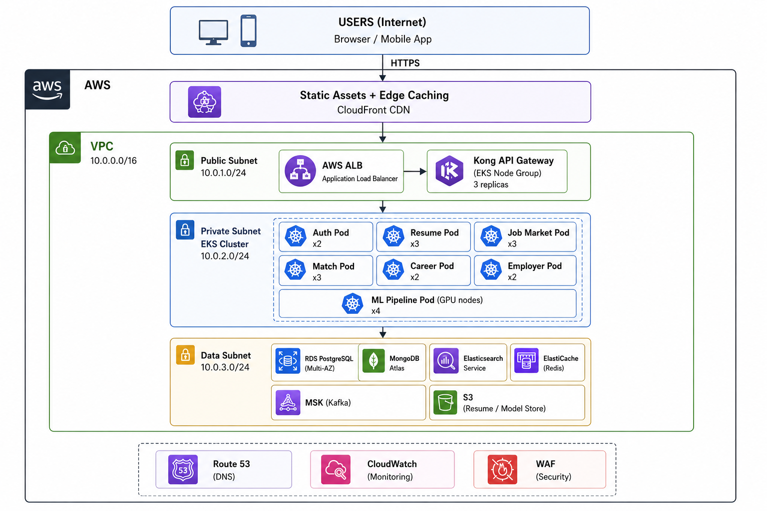

3.6 Component Diagram (UML)
The UML Component Diagram shows the internal structure and interfaces of the major subsystems.

UML COMPONENT DIAGRAM — AJMIRAS SUBSYSTEMS
┌──────────────────────────────────────────────────────────────────┐
│ <<component>> │
│ Frontend Layer (React SPA) │
│ ┌────────────┐ ┌───────────────┐ ┌──────────────────────┐ │
│ │ ResumePage │ │ JobMarketPage │ │ EmployerDashboard │ │
│ │ Component │ │ Component │ │ Component │ │
│ └────┬───────┘ └───────┬───────┘ └──────────┬──────────┘ │
└───────┼──────────────────┼─────────────────────┼──────────────┘
│ REST/HTTPS │ │
┌───────▼──────────────────▼─────────────────────▼──────────────┐
│ <<component>> API Gateway │
│ ┌──────────┐ ┌──────────────┐ ┌──────────┐ ┌──────────┐ │
│ │ Auth │ │ Rate Limiter │ │ Router │ │ Logger │ │
│ │ Filter │ │ Module │ │ Module │ │ Module │ │
│ └──────────┘ └──────────────┘ └──────────┘ └──────────┘ │
└───────┬──────────────────────────────────────────────────────┘
│ Internal REST
┌───────▼────────────────────────────────────────────────────────┐
│ <<component>> Business Services Layer │
│ ┌─────────────┐ ┌────────────────┐ ┌──────────────────┐ │
│ │ Auth │ │ Resume Service │ │ Job Market Svc │ │
│ │ Service │ │ ┌──Parser──┐ │ │ ┌─Aggregator──┐ │ │
│ │ │ │ │ ┌Scorer─┐│ │ │ │ ┌Classifier┐│ │ │
│ │ │ │ │ └───────┘│ │ │ │ └──────────┘│ │ │
│ └─────────────┘ │ └──────────┘ │ │ └────────────┘ │ │
│ ┌─────────────┐ └────────────────┘ └──────────────────┘ │
│ │ Matching │ ┌────────────────┐ ┌──────────────────┐ │
│ │ Service │ │ Career Path │ │ Employer Service │ │
│ │ ┌NLP Engine┐│ │ Service │ │ ┌Analytics──┐ │ │
│ │ └──────────┘│ │ ┌GapAnalyzer─┐ │ │ └──────────┘ │ │
│ └─────────────┘ │ └────────────┘ │ └──────────────────┘ │
└───────────────────┴────────────────┴────────────────────────┘
│ via Kafka Events / Direct DB
┌───────▼────────────────────────────────────────────────────────┐
│ <<component>> Data Layer │
│ ┌──────────┐ ┌──────────┐ ┌──────────────┐ ┌──────────┐ │
│ │PostgreSQL│ │ MongoDB │ │Elasticsearch │ │ Redis │ │
│ └──────────┘ └──────────┘ └──────────────┘ └──────────┘ │
└────────────────────────────────────────────────────────────────┘

3.7 Data Architecture
The system uses a polyglot persistence strategy. Each database is selected for the access pattern of its owning service.

Database | Type | Owner Service | Key Entities Stored
PostgreSQL 15 | Relational | Auth, Employer, Admin | Users, Roles, Jobs, Scores, Audit Logs, Subscriptions
MongoDB 7 | Document | Resume Service | ResumeDocument, ParsedData, AnalysisReport, FeedbackHistory
Elasticsearch 8 | Search Index | Job Market, Matching | JobPostings (full-text + vector), ResumeIndex, SkillTaxonomy
Redis 7 | Cache / KV | API Gateway, All | Sessions, Rate-Limit Counters, Job Match Cache, ML Result Cache
Kafka (MSK) | Event Stream | All Services | ResumeUploadedEvent, JobScrapedEvent, MatchRequestedEvent
S3 / Blob | Object Store | Resume, ML Services | Raw Resume Files, Trained ML Model Artifacts, Report Exports

3.8 ER Diagram — Core Entities
Key relational entities managed by PostgreSQL are shown below.

ER DIAGRAM — CORE RELATIONAL ENTITIES (PostgreSQL)
┌──────────────────┐ ┌──────────────────────┐
│ USER │ │ SUBSCRIPTION │
│──────────────────│ 1 1 │──────────────────────│
│ PK user_id UUID ├─────────┤ PK sub_id │
│ email │ │ FK user_id │
│ password_hash │ │ tier (free/pro) │
│ role │ │ expires_at │
│ created_at │ └──────────────────────┘
└──────┬───────────┘
│ 1
│ has many
│ N
┌──────▼───────────┐ N 1 ┌───────────────────┐
│ RESUME │──────────┤ RESUME_SCORE │
│──────────────────│ │───────────────────│
│ PK resume_id │ │ PK score_id │
│ FK user_id │ │ FK resume_id │
│ file_ref S3 │ │ total_score │
│ status │ │ ats_score │
│ uploaded_at │ │ keyword_score │
└──────────────────┘ │ created_at │
└───────────────────┘

┌──────────────────┐ N 1 ┌───────────────────┐
│ JOB_POSTING │ │ EMPLOYER │
│──────────────────│ │───────────────────│
│ PK job_id UUID ├──────────┤ PK employer_id │
│ FK employer_id │ │ FK user_id │
│ title │ │ company_name │
│ description │ │ verified │
│ skills_req │ └───────────────────┘
│ salary_min/max│
│ location │ N N ┌───────────────────┐
│ posted_at ├──────────┤ JOB_MATCH │
└──────────────────┘ │───────────────────│
│ PK match_id │
│ FK job_id │
│ FK user_id │
│ score (0-100) │
│ created_at │
└───────────────────┘

3.9 Class Diagram — Resume Analysis Domain

CLASS DIAGRAM — RESUME ANALYSIS DOMAIN
┌──────────────────────────────┐
│ <<class>> ResumeService │
│──────────────────────────────│
│ - parser: ResumeParser │
│ - scorer: ScoringEngine │
│ - repo: ResumeRepository │
│──────────────────────────────│
│ + uploadResume(file): Resume │
│ + analyzeResume(id): Report │
│ + getScore(id): ScoreResult │
└──────────────┬───────────────┘
uses │ uses
┌─────────────┘ └──────────────────────┐
▼ ▼
┌────────────────────────┐ ┌────────────────────────────┐
│ <<class>> ResumeParser│ │ <<class>> ScoringEngine │
│────────────────────────│ │────────────────────────────│
│ - nlpModel: NLPModel │ │ - weights: ScoringWeights │
│────────────────────────│ │ - llmClient: LLMClient │
│ + parse(file): ParsedCV│ │────────────────────────────│
│ + extractSkills() │ │ + score(cv, jd): ScoreResult│
│ + extractExperience() │ │ + suggestImprovements() │
│ + extractEducation() │ │ + detectBias() │
└────────────────────────┘ └────────────────────────────┘
│ │
▼ creates ▼ creates
┌────────────────────────┐ ┌────────────────────────────┐
│ <<class>> ParsedCV │ │ <<class>> ScoreResult │
│────────────────────────│ │────────────────────────────│
│ + contactInfo: Contact │ │ + totalScore: int │
│ + skills: List<Skill> │ │ + atsScore: int │
│ + experience: List<Exp>│ │ + keywordScore: int │
│ + education: List<Edu> │ │ + suggestions: List<String>│
│ + certifications: List │ │ + biasFlags: List<String> │
└────────────────────────┘ └────────────────────────────┘

Chapter 4 — User Interface Design

4.1 UI Design Principles
- Clarity First — Complex AI outputs (scores, suggestions) rendered in plain language with visual affordance.
- Progressive Disclosure — Advanced features revealed contextually; avoid overwhelming new users.
- Accessibility — WCAG 2.1 Level AA compliance; keyboard navigation, ARIA labels, screen-reader support.
- Responsive Design — Mobile-first breakpoints: 360px, 768px, 1024px, 1440px+.
- Dark / Light Mode — System preference detection + user override in settings.

4.2 Design System
Element | Specification | Notes
Primary Color | #1F3864 (Navy) | Headers, primary CTAs, brand elements
Secondary Color | #2E75B6 (Blue) | Links, secondary actions, highlights
Accent Color | #4472C4 (Lighter Blue) | Charts, tags, score bars
Success | #217346 (Green) | Score pass, completed items
Warning | #C9791A (Amber) | Partial match, review needed
Danger | #C00000 (Red) | Low score, error states
Typography — Body | Inter 14px / 22px line-height | System-UI fallback stack
Typography — Heading | Inter Bold 24–48px | Variable weights 600–800
Spacing Unit | 8px base grid | All spacing in multiples of 8
Border Radius | 8px components, 4px inputs | Rounded modern aesthetic
Shadow | 0 2px 12px rgba(0,0,0,0.08) | Elevation for cards and modals

4.3 Screen Wireframes (Textual Representation)

4.3.1 Job Seeker Dashboard
WIREFRAME: Job Seeker Dashboard
╔══════════════════════════════════════════════════════════════════╗
║ AJMIRAS Logo [Search Jobs...] [Bell] [Avatar] [Pro]║
╠══════════════════════════════════════════════════════════════════╣
║ [Dashboard] [My Resume] [Job Matches] [Career Path] [Market] ║
╠══════════╦═══════════════════════════════════════════╦══════════╣
║ ║ ║ ║
║ LEFT ║ RESUME SCORE CARD [Upload New] ║ RIGHT ║
║ PANEL ║ ┌──────────────────────────────────┐ ║ PANEL ║
║ ║ │ Overall Score: 78 / 100 ████░░│ ║ ║
║ Quick ║ │ ATS Score: 82 ████████░ │ ║ Job ║
║ Stats ║ │ Keyword Match: 71 ███████░░ │ ║ Match ║
║ ────── ║ │ [View Full Analysis] [Improve] │ ║ Count ║
║ 12 New ║ └──────────────────────────────────┘ ║ ────── ║
║ Matches ║ ║ 47 ║
║ ║ TOP JOB MATCHES [See All ▶] ║ Active ║
║ 3 Alerts║ ┌──────────┐ ┌──────────┐ ┌──────────┐ ║ Jobs ║
║ ║ │Sr Dev │ │Data Sci │ │ML Eng │ ║ ║
║ Skills ║ │Google │ │Microsoft │ │Meta │ ║ Market ║
║ Gap: 3 ║ │93% Match │ │88% Match │ │85% Match │ ║ Trend ║
║ ║ │[Apply] │ │[Apply] │ │[Save] │ ║ Graph ║
║ ║ └──────────┘ └──────────┘ └──────────┘ ║ ║
╚══════════╩═══════════════════════════════════════════╩══════════╝

4.3.2 Resume Analysis View
WIREFRAME: Resume Upload & Analysis View
┌──────────────────────────────────────────────────────────────┐
│ │
│ ┌──────────────────────────────────────────────────────┐ │
│ │ UPLOAD RESUME │ │
│ │ ┌──────────────────────────────────────────┐ │ │
│ │ │ DROP FILE HERE │ │ │
│ │ │ PDF, DOCX, TXT (max 5 MB) │ │ │
│ │ │ [📄 Browse Files] │ │ │
│ │ └──────────────────────────────────────────┘ │ │
│ │ Compare to: [Job Description Text ▼] (optional) │ │
│ │ [Analyze Resume →] │ │
│ └──────────────────────────────────────────────────────┘ │
│ │
│ ANALYSIS RESULTS │
│ ┌───────────────┐ ┌───────────────────────────────────┐ │
│ │ SCORE 78 │ │ SECTIONS BREAKDOWN │ │
│ │ ████████░░ │ │ ✅ Contact Info ──────── 100% │ │
│ │ │ │ ✅ Work Experience ───── 85% │ │
│ │ [Excellent] │ │ ⚠️ Skills Section ────── 72% │ │
│ │ │ │ ❌ Summary / Objective ─ 40% │ │
│ └───────────────┘ │ ⚠️ Education ──────────── 78% │ │
│ └───────────────────────────────────┘ │
│ TOP SUGGESTIONS │
│ 1. Add a professional summary (currently missing) │
│ 2. Include 3+ missing keywords: 'Kubernetes', 'CI/CD' │
│ 3. Quantify achievements in work experience section │
└──────────────────────────────────────────────────────────────┘

4.4 Navigation Flow
All navigation follows a flat, role-based hierarchy. Maximum depth is 3 levels (Dashboard → Feature → Detail). Role-based routing enforced at the API Gateway; unauthorized routes return 403 and redirect to login.

4.5 Responsive Breakpoints
Breakpoint | Viewport | Layout Behaviour
xs (Mobile) | < 480px | Single column, hamburger nav, stacked cards, bottom tab bar
sm (Mobile L) | 480–767px | Single column, expanded nav drawer
md (Tablet) | 768–1023px | Two-column grid, side drawer nav
lg (Desktop) | 1024–1439px | Three-column grid, persistent sidebar
xl (Wide) | >= 1440px | Full dashboard layout with side-by-side panels

Chapter 5 — UML Diagrams

5.1 Use Case Diagram — Full System
This diagram covers all actors and use cases across the complete AJMIRAS boundary.
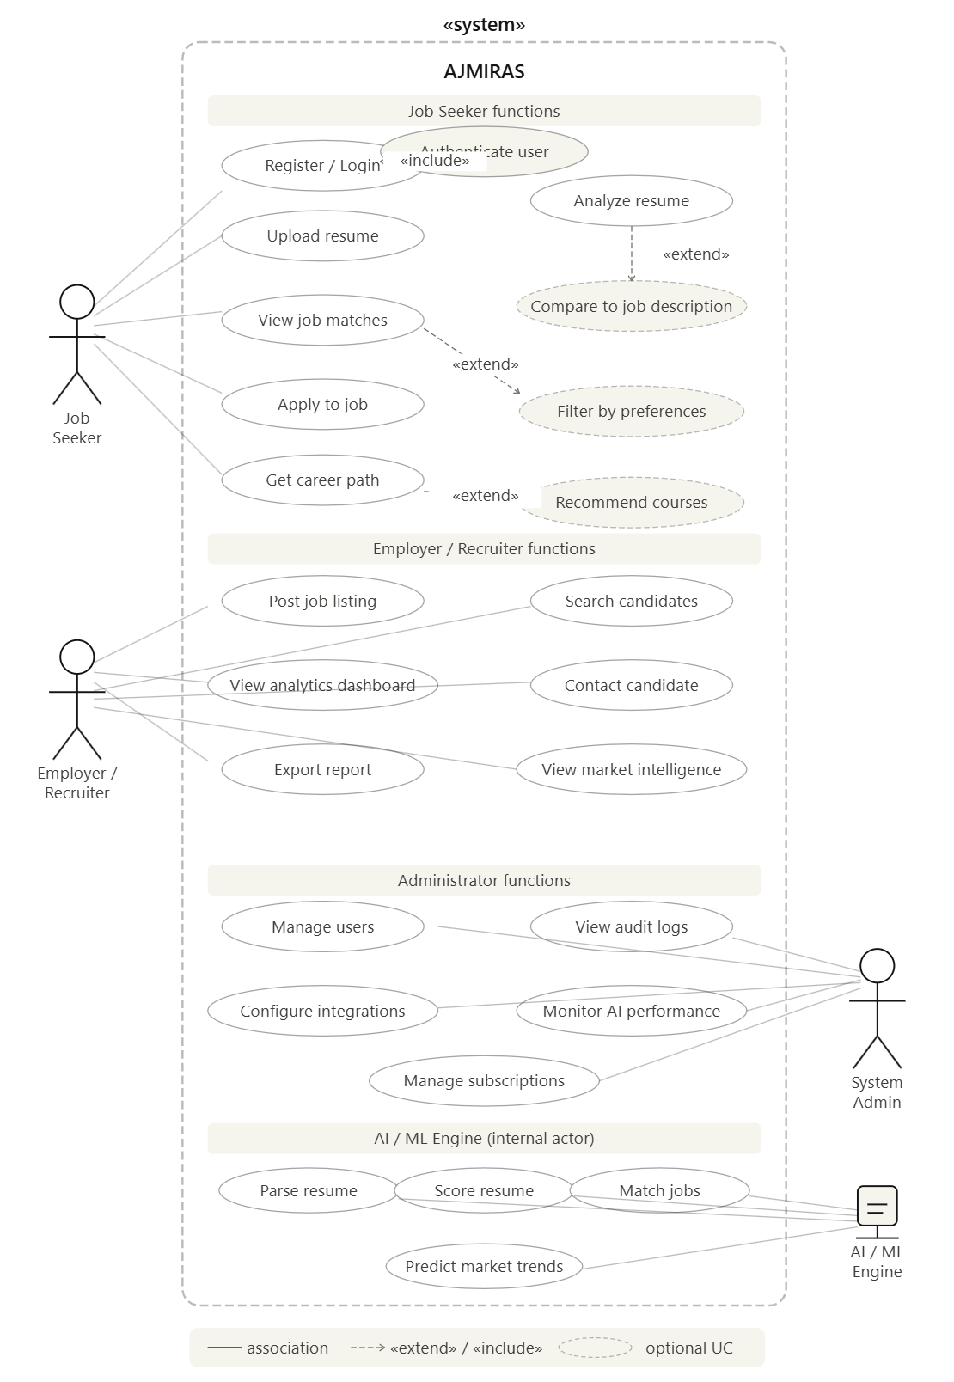

5.2 Activity Diagram — Resume Analysis Workflow

ACTIVITY DIAGRAM — RESUME ANALYSIS WORKFLOW
──────────────────────────────────────────────────────────────────────
● START
│
▼
[User Uploads Resume File]
│
▼
<File Format Valid? PDF / DOCX / TXT>
│ No │ Yes
▼ ▼
[Show Format Error] [Store Raw File → S3]
│ │
│ ▼
│ [Publish ResumeUploadedEvent → Kafka]
│ │
│ ▼
│ [ML Pipeline Consumes Event]
│ │
│ ├──── [Extract Text from File]
│ │
│ ├──── [NLP: Parse Sections]
│ │ ├── Contact Info
│ │ ├── Work Experience
│ │ ├── Skills
│ │ ├── Education
│ │ └── Certifications
│ │
│ ├──── <Job Description Provided?>
│ │ │ Yes │ No
│ │ ▼ ▼
│ │ [Keyword Gap [Use General
│ │ Analysis] Industry Benchmark]
│ │ │ │
│ │ └─────────┬─────────┘
│ │ │
│ ├──── [Score Resume (0-100)]
│ │ ├── ATS Compatibility Score
│ │ ├── Content Completeness Score
│ │ └── Keyword Relevance Score
│ │
│ ├──── [LLM: Generate Suggestions]
│ │
│ ├──── [Bias Check on Content]
│ │
│ ▼
│ [Save AnalysisReport → MongoDB]
│ │
│ ▼
│ [Push WebSocket Notification → Frontend]
│ │
└──────────────────────►▼
[Display Results to User]
│
● END

5.3 Activity Diagram — Job Matching Workflow

ACTIVITY DIAGRAM — INTELLIGENT JOB MATCHING
──────────────────────────────────────────────────────────────────────
● START (Triggered daily at 02:00 UTC or on-demand by user)
│
▼
[Load Active User Profiles with Parsed CVs]
│
▼
[Load Active Job Postings from Elasticsearch Index]
│
▼
[For each User Profile:] ─── (parallel fork) ─────────────────────┐
│ │
▼ ▼
[Generate User Embedding Vector (BERT/sentence-transformers)] [Repeat]
│
▼
[Query Elasticsearch KNN Search — Top-50 candidate jobs]
│
▼
[Re-rank using ML Scoring Model]
│ Factors: Skills overlap, Experience level, Location, Salary range
│
▼
[Apply User-set Filters (location / salary / job type)]
│
▼
[Take Top-20 Ranked Matches]
│
▼
[Store Matches → PostgreSQL job_matches table]
│
▼
<New high-score matches (>=90%) found since last run?>
│ Yes │ No
▼ │
[Send Email / Push Alert] │
│ │
└───────────────────────────┘
│
▼
[Record Engagement Feedback for Reinforcement Loop]
│
● END

5.4 Sequence Diagram — Resume Upload and Analysis

SEQUENCE DIAGRAM — RESUME UPLOAD & ANALYSIS
──────────────────────────────────────────────────────────────────────
User Browser API GW Auth Svc Resume Svc ML Pipeline LLM API
│ │ │ │ │ │ │
│─Upload ───►│ │ │ │ │ │
│ │─POST /api/─► │ │ │ │
│ │ resume/upload │ │ │ │
│ │ │─Validate──►│ │ │ │
│ │ │ JWT Token │ │ │ │
│ │ │◄─ 200 OK ──│ │ │ │
│ │ │─Route req─►│ │ │ │
│ │ │ │─Store S3──► │ │
│ │ │ │ (async) │ │ │
│ │ │ │─Pub Kafka─► │ │
│ │ │ │ Event │ │ │
│ │◄─202 Accepted──────────◄│ │ │ │
│ │ │ │ │◄─Consume───│ │
│◄─Progress──│(WebSocket) │ │ │ Event │ │
│ Notification│ │ │ │─Parse NLP──► │
│ │ │ │ │ │─Score &──► │
│ │ │ │ │ │ Suggest │
│ │ │ │ │ │◄─Result────│
│ │ │ │ │◄──Analysis─│ │
│ │ │ │ │ Report │ │
│ │ │ │ │─Save MongoDB │
│ │ │ │ │─WebSocket Notify │
│◄─Results───│ │ │ │ │ │
│ Dashboard │ │ │ │ │ │

5.5 Sequence Diagram — User Authentication (MFA)

SEQUENCE DIAGRAM — USER LOGIN WITH MFA
──────────────────────────────────────────────────────────────────────
User Browser API GW Auth Svc Redis SendGrid
│ │ │ │ │ │
│─Login form──►│ │ │ │ │
│ │─POST /auth/─► │ │ │
│ │ login │─Route ─────►│ │ │
│ │ │ │─Verify pwd │ │
│ │ │ │ (bcrypt) │ │
│ │ │ │─Store OTP─►│ │
│ │ │ │ (5 min │ │
│ │ │ │ TTL) │ │
│ │ │ │─Send OTP email─────────►│
│◄─MFA prompt──│ │ │ │ │
│ │ │ │ │ │
│─Enter OTP───►│ │ │ │ │
│ │─POST /auth/─► │ │ │
│ │ verify-mfa │─Route ─────►│ │ │
│ │ │ │─Check OTP─►│ │
│ │ │ │◄─Match─────│ │
│ │ │ │─Issue JWT │ │
│ │ │ │ (Access + │ │
│ │ │ │ Refresh) │ │
│◄─JWT Tokens──│◄────────────◄────────────◄│ │ │
│ │ │ │ │ │

5.6 State Machine Diagram — Resume Lifecycle

STATE MACHINE DIAGRAM — RESUME LIFECYCLE
──────────────────────────────────────────────────────────────────────
● INITIAL
│
▼
┌─────────────────────────┐
│ UPLOADED │ ── trigger: file received & validated
└────────────┬────────────┘
│ [Kafka event published]
▼
┌─────────────────────────┐
│ PARSING │ ── ML pipeline extracts text & structure
└────────────┬────────────┘
│ [Parse complete]
┌────────────┴────────────────────────────────────┐
│ parse failed? │ parse OK
▼ ▼
┌─────────────────────────┐ ┌─────────────────────────────┐
│ PARSE_FAILED │ │ SCORING │
│ (notify user) │ │ (0-100 score calculated) │
└─────────────────────────┘ └────────────┬────────────────┘
│ [score complete]
▼
┌─────────────────────────────┐
│ ANALYZED │
│ (report available to user) │
└────────────┬────────────────┘
┌──────────────────┬────────┴────────────────┐
│ [user re-uploads] │ [user updates profile] │ [user deletes]
▼ ▼ ▼
[UPLOADED state] ┌───────────────┐ ┌──────────────┐
│ OUTDATED │ │ DELETED │
│ (score stale)│ │ (GDPR purge)│
└───────────────┘ └──────────────┘
│
◎ FINAL

5.7 State Machine Diagram — Job Posting Lifecycle

STATE MACHINE DIAGRAM — JOB POSTING LIFECYCLE
──────────────────────────────────────────────────────────────────────
● START
│
▼
┌──────────────────┐
│ DRAFT │ ── employer creates posting
└────────┬─────────┘
│ [submit for review]
▼
┌──────────────────┐
│ UNDER_REVIEW │ ── content moderation check (bias language filter)
└────────┬─────────┘
┌────────┴────────────────────────────┐
│ rejected (discriminatory content) │ approved
▼ ▼
┌──────────────────┐ ┌──────────────────────┐
│ REJECTED │ │ ACTIVE │
│ (notify employ.)│ │ (visible, matching) │
└──────────────────┘ └──────────┬───────────┘
┌───────────┴──────────────────┐
│ [closing date passed] │ [employer closes]
▼ ▼
┌──────────────────┐ ┌──────────────────────┐
│ EXPIRED │ │ CLOSED │
│ (auto-archived) │ │ (manual close) │
└──────────────────┘ └──────────────────────┘
│ │
└──────────────┬───────────────┘
▼
┌──────────────────┐
│ ARCHIVED │
│ (read-only, │
│ analytics) │
└──────────────────┘
│
◎ FINAL

5.8 Sequence Diagram — Employer Posts a Job

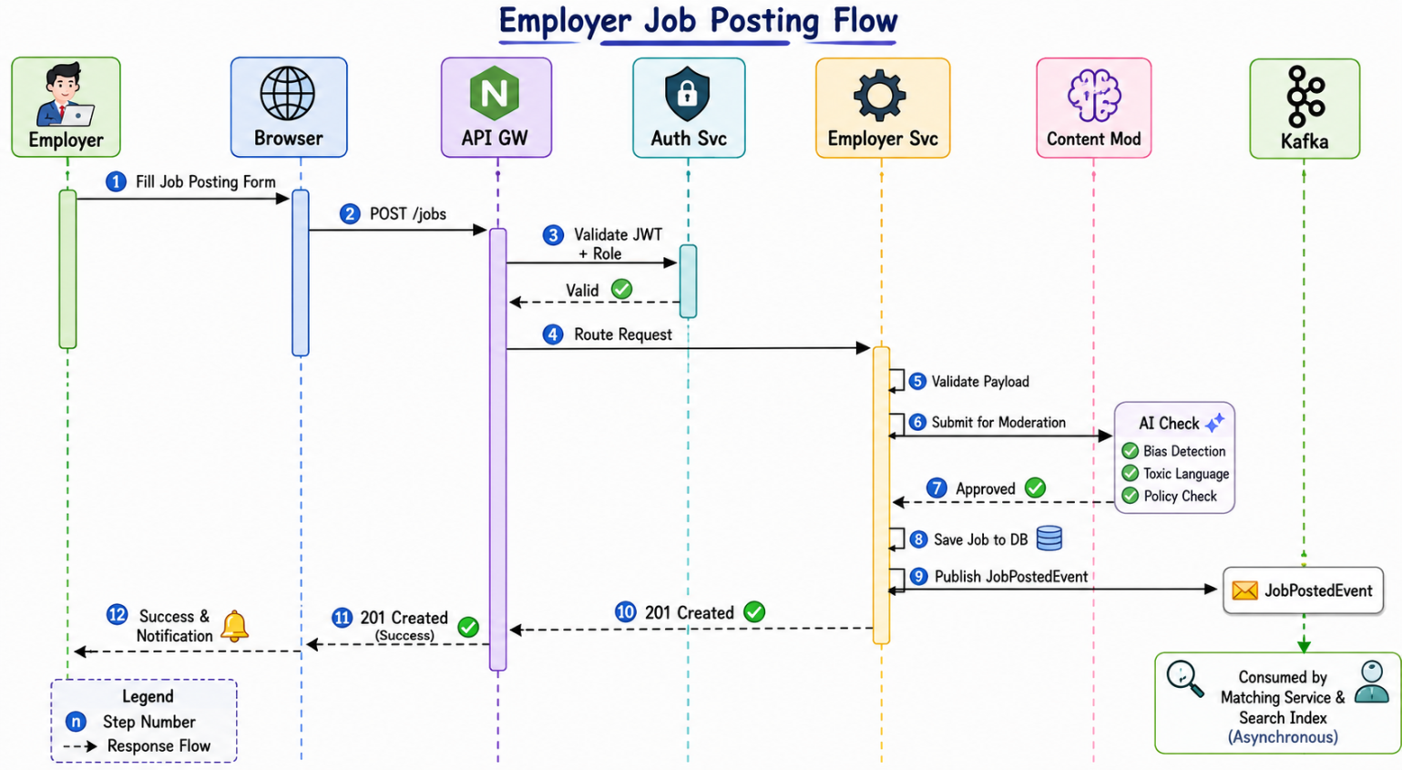

5.9 Activity Diagram — Career Path Recommendation

ACTIVITY DIAGRAM — CAREER PATH RECOMMENDATION
──────────────────────────────────────────────────────────────────────
● START (User sets Target Role in Profile)
│
▼
[Load User's Current Skills from Parsed CV]
│
▼
[Load Target Role Requirements from O*NET / Job Posting Data]
│
▼
[Compute Skill Gap = TargetSkills − CurrentSkills]
│
▼
<Gap set empty?>
│ Yes │ No
▼ ▼
[User is [Prioritize gaps by market demand weight]
Job-ready!] │
│ ▼
│ [For each gap skill: Query Course APIs]
│ │ ├─ Coursera API
│ │ ├─ Udemy API
│ │ └─ LinkedIn Learning API
│ │
│ ▼
│ [LLM: Generate Personalized Learning Roadmap]
│ │
│ ▼
│ [Estimate Timeline (weeks per skill)]
│ │
│ ▼
│ [Estimate Salary Growth at each milestone]
│ │
└──────────────────►▼
[Render Career Roadmap Timeline + Courses]
│
▼
<User marks skill as learned?>
│ Yes │ No
▼ ▼
[Update Profile] [Keep Suggestion Active]
│ │
└──────────┬────────┘
│
◎ END

Chapter 6 — References

All standards, specifications, and external resources referenced in this Software Design Document are listed below. Version numbers and URLs are recorded as of the document date (June 2026).

ID | Source | Description / URL
[R1] | IEEE/ISO/IEC 42010:2011 | Systems and software engineering — Architecture description
[R2] | SRS v1.2 (2026) | AI-Based Job Market Intelligence and Resume Analysis System — Muhammad Shahid
[R3] | Anthropic Claude API Docs | https://docs.anthropic.com — LLM integration reference
[R4] | OpenAPI Specification 3.0 | https://swagger.io/specification/ — REST API contract format
[R5] | OWASP ASVS v4.0 | Application Security Verification Standard — https://owasp.org/ASVS
[R6] | NIST SP 800-53 Rev 5 | Security and Privacy Controls for Information Systems
[R7] | WCAG 2.1 | Web Content Accessibility Guidelines — https://www.w3.org/TR/WCAG21/
[R8] | GDPR (EU 2016/679) | General Data Protection Regulation — data privacy compliance
[R9] | The Twelve-Factor App | https://12factor.net — Cloud-native application design methodology
[R10] | O*NET OnLine | https://www.onetonline.org — Occupational taxonomy and skill data
[R11] | AWS Well-Architected Framework | https://aws.amazon.com/architecture/well-architected/
[R12] | HuggingFace Transformers | https://huggingface.co/docs/transformers — NLP model library
[R13] | React 18 Docs | https://react.dev — Frontend framework documentation
[R14] | Kubernetes Docs | https://kubernetes.io/docs — Container orchestration reference
[R15] | Apache Kafka Docs | https://kafka.apache.org/documentation — Event streaming platform
[R16] | PostgreSQL 15 Docs | https://www.postgresql.org/docs/15/ — RDBMS reference
[R17] | Elasticsearch 8 Docs | https://www.elastic.co/guide/index.html — Search engine reference

Appendix A — Glossary
Term | Definition
AJMIRAS | AI-Based Job Market Intelligence and Resume Analysis System — the platform described in this SDD.
API Gateway | Single entry-point service that handles routing, authentication, rate-limiting, and SSL termination.
ATS | Applicant Tracking System — software used by employers to manage job applications.
Bounded Context | DDD concept: a clear boundary within which a particular domain model applies consistently.
C4 Model | Hierarchical architecture modelling method: Context, Containers, Components, Code.
GDPR | General Data Protection Regulation — EU data privacy law applicable to all user data.
HPA | Horizontal Pod Autoscaler — Kubernetes mechanism to scale pods based on CPU/memory metrics.
JWT | JSON Web Token — stateless authentication token used for API authorization.
Kafka | Apache Kafka — distributed event streaming platform used for async microservice communication.
KNN | K-Nearest Neighbours — vector similarity search algorithm used in job-candidate matching.
LLM | Large Language Model — AI model (e.g. Claude, GPT-4) used for NLP generation tasks.
MFA | Multi-Factor Authentication — additional login verification beyond username/password.
NLP | Natural Language Processing — AI techniques for parsing and understanding human text.
O*NET | Occupational Information Network — US government database of job roles and required skills.
RBAC | Role-Based Access Control — access restriction based on user roles.
RPO | Recovery Point Objective — maximum acceptable data loss measured in time.
RTO | Recovery Time Objective — maximum acceptable downtime after a system failure.
SaaS | Software as a Service — cloud-delivered software subscription model.
SDD | Software Design Document — this document; translates SRS requirements into design blueprints.
SRS | Software Requirements Specification — the source requirements document for AJMIRAS.
WebSocket | Bidirectional persistent connection protocol used for real-time dashboard notifications.

